EENG 284

–

Digital Design Lab

How To: Synthesize a Module

The combinedLab01 verilog file used in this example has three inputs and three outputs that are mapped to slide switches and LEDs.

**Synthesizing a Verilog Module**

It’s time to realize the *combinedLab01* Verilog file to FPGA. To do this follow these steps:

1. In Project Navigator pane, select the File tab
2. Right mouse click *combinedLab01.v* and select Set As Top Level Entity.
3. Processing -> Start -> Start Analysis and Elaboration
4. Assignments -> Pin Planner
5. In the Pin Planner pop-up you should see the pin assignment pane at the bottom of the window.

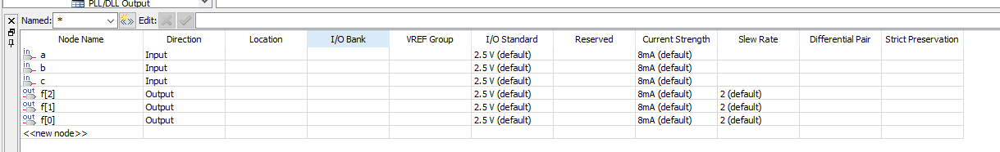

1. Double click in the Location cell for row c
2. Scroll down the list of pins to PIN_AC9
3. Complete the pin assignment for the other 5 inputs and outputs using the information contained in pin assignment table completed earlier.
4. Double check your pin assignments.
5. File -> Close. Note closing your file incorporates this assignment into the project.
6. Back in the Quartus window, Processing -> Start Compilation <Ctrl-L>
7. Tools -> Programmer
8. In the Programmer pop-up window click Add File…
9. In the Select Programming File pop-up, navigate to your project directory, then into the output files folder, the select combinedLab01.sof, click Open. You should see something like the following.

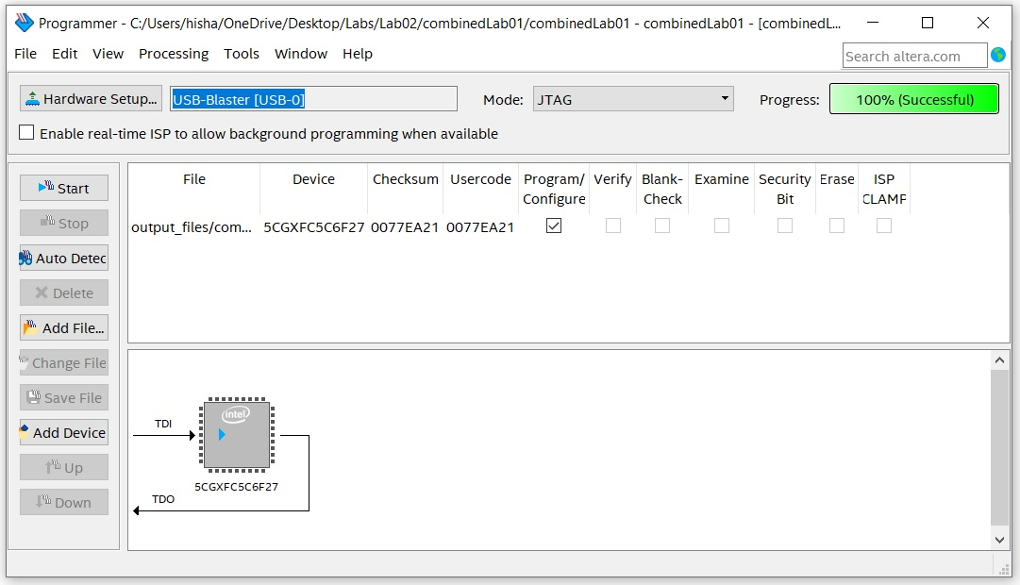

1. Connect the Altera Cyclone V GX FPGA to your computer through the USB port, connect the power supply, and push the red power-on button. Try not to be annoyed by the infernal blinking LEDs.
2. In the Programmer pop-up
   1. Click Hardware Setup….
   2. In the Hardware Setup select USB-Blaster [USB=0] from the Currently selected hardware pull-down
   3. Click Close
3. Back in the Programmer window, the box next to Hardware Setup… should reflect your choice. Click Start,
4. The Development board should stop its infernal blinking and run your program. You may notice that the unused LEDs are dimly illuminated.

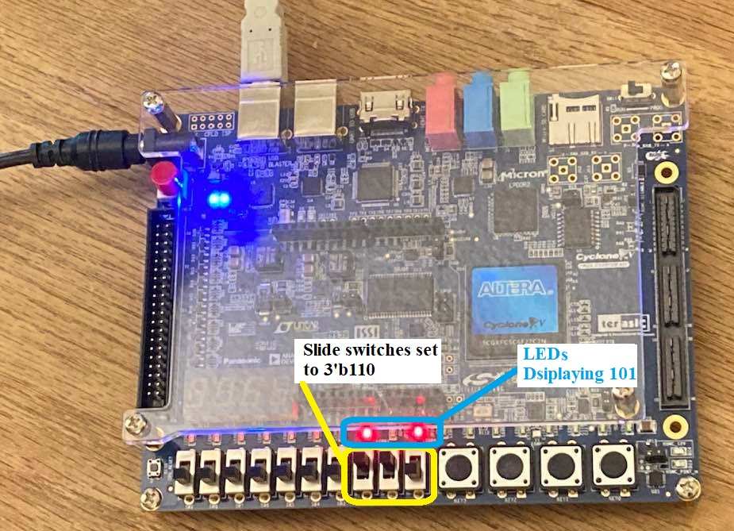

Figure 6: The Development board properly configured and running the combinedLab01 Verilog file.